
FACULTY OF ENGINEERING & TECHNOLOGY
ASSIGNMENT REPORT ON ALGORITHM DEVELOPMENT, CONTROL STRUCTURES USING THE KNOWLEDGE OF MATLAB MODULES 1-4
COMPUTER PROGRAMMING
COURSE LECTURER: MR. MASERUKA BENDICTO

By GROUP 18

ABSTRACT
This report looks at the numerical approximation methods for finding solutions to functions that is Newton Raphson Method, secant method, bisection method and fixed point iteration. It further more looks at the methods for solving differential equations numerically and they include Euler method and Runge-Kutta. The above methods were designed in the MATLAB environment that is the Live Script. Graphs are also added to compare the problems analytical solutions obtained by the different methods. The project demonstrated fundamental skills in data handling, organization, and problem-solving within the MATLAB environment, providing practical experience in a complete data workflow.

ACKNOWLEGEMENT
By the Grace of GOD we were able to work together as a group to complete the assignment and we acknowledge him for that.
We thank, Mr. Maseruka Bendicto our course lecturer for guiding us in this course which is a vital aspect for our engineering profession.
Appreciation goes to group members for the commitment and team spirit which simplified work and made it easy for us to complete the task and come up with this report.

DECLARATION
We, Group 18 members hereby declare to the best of our knowledge, that this assignment report is a true record of our unending efforts in applying the knowledge we acquired from modules one through four. It is truly an original creation of our own and it has never been used by any other individual for any academic award in any learning institution.
MEMBERS OF GROUP 18
 | NAME | REG NUMBER | PROGRAM | SIGN
1 | AUMA DIANA | BU/UP/2024/1020 | WAR
2 | ENAMU REAGAN EGIMU | BU/UG/2024/2672 | APE
3 | MUKHOOLI ELIJAH | BU/UG/2024/2586 | MEB
4 | NABAWEESI CLAIRE | BU/UP/2024/1046 | WAR
5 | NAKAWEESA LINNET | BU/UP/2024/4327 | APE
6 | NANDAULA CATHERINE | BU/UP/2024/4322 | AMI
7 | OLUK CHRISTIAN GLEN | BU/UP/2024/3842 | WAR
8 | OMARA PASCAL KELLY | BU/UP/2024/1063 | WAR
9 | TUMUHAISE SARAH | BU/UG/2024/2674 | AMI
10 | UHURU DENISH BRIAN | BU/UP/2024/3841 | WAR

APPROVAL
This is to confirm that this report has been written and presented by Group 18, giving details of the assignment carried out.
Course Lecturer
Signature | _____________________________
Date | _____________________________

: INTRODUCTION
In this assignment we were required to using code within the MATLAB environment. In order to determine a root it is usually essential to have an initial estimate of its value. In some cases you may have more than one root (or none) and you wish to identify which one you are concerned with. The method we will describe now involves user interaction and is used as an illustration. As we are developing the ideas in this report we could consider how they could be generalized to include root selection. In general the methods we have talked about will require either an initial guess for the root or a bracketing interval containing a root. We were required to ensure that the different numerical methods were tested and that this would help us to plot graphs and compare the problem analytical solutions obtained along with the computation time.
TASK GIVEN
In your different groups, utilize the knowledge of algorithms development, control structures and modules 1-4 on the following problems
- All Numerical approximate methods for finding the solutions to functions, these include but are not limited to ; Newton Raphson
- All methods for solving differential equations numerically these include but are not limited to; Euler, Runge-kutta.
- Ensure to apply a and b on a practical real world problem
Note: requirements; ensure that different methods are stated on similar problems each (minimum of 2). This will help u to plot graphs that compare the problems analytical solutions to the solutions obtained by the different methods along with the computation time.
Solution to the question
Here is the question we are trying to solve using Newton’s Raphson method, secant method, Bisection method and then fixed iteration
Solve $x^{3}-5x+3=0$
Below are the flow charts;
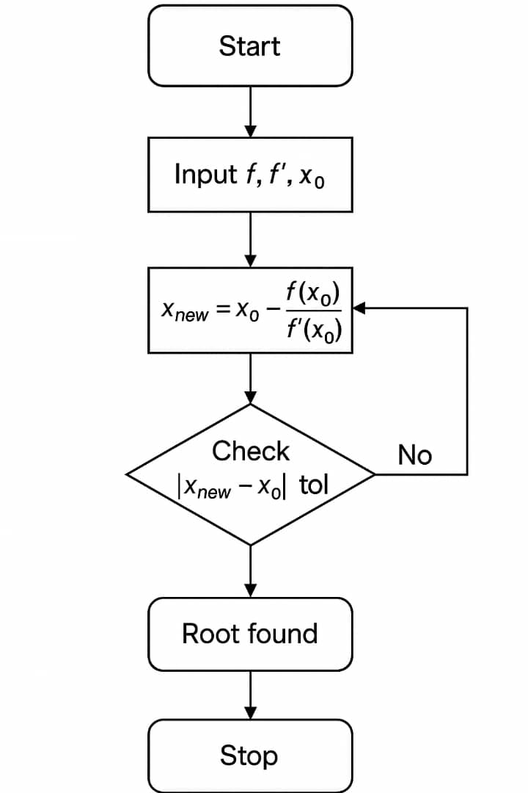
            - Newton’s Raphson Method
Pseudo Codes for the flow Chart
Input: function f(x), derivative f’(x), initial guess x0, tolerance tol, maxIter
For k = 1 to maxIter
x_new = x0 - f(x0) / f’(x0)
If |x_new - x0| < tol
Root = x_new
Stop
End If
x0 = x_new
End For
Output: Root
            - Secant Method
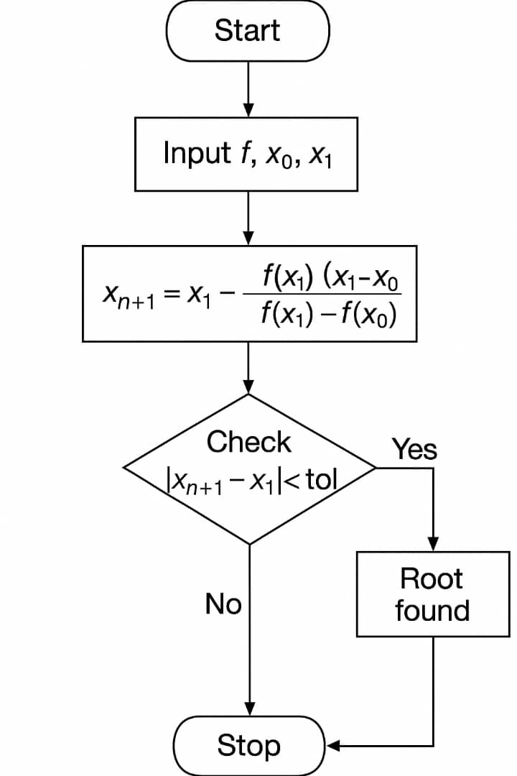
Pseudo code for the flow chart above
Input: f(x), two guesses x0, x1, tolerance tol, maxIter
For k = 1 to maxIter
x_new = x1 - f(x1)*(x1 - x0)/(f(x1) - f(x0))
If |x_new - x1| < tol
Root = x_new
Stop
End If
x0 = x1
x1 = x_new
End For
Output: Root
Combine codes for Newton and Secant Methods
%%Root Finding using Newton-Raphson and Secant Methods
clc; clear; close all;

f = @(x) x.^3 - 5*x + 3; % Function
df = @(x) 3*x.^2 - 5; % Derivative for Newton-Raphson

% Initial guesses
x0 = 1; % initial guess for Newton-Raphson
x1 = 0; % first guess for Secant
x2 = 1; % second guess for Secant

tol = 1e-6;
maxIter = 50;

% Newton-Raphson
tic;
for k = 1:maxIter
x_new = x0 - f(x0)/df(x0);
if abs(x_new - x0) < tol
break;
end
x0 = x_new;
end
NR_root = x_new;
NR_time = toc;

% Secant Method
tic;
for k = 1:maxIter
x_new = x2 - f(x2)*(x2-x1)/(f(x2)-f(x1));
if abs(x_new - x2) < tol
break;
end
x1 = x2;
x2 = x_new;
end
Sec_root = x_new;
Sec_time = toc;

fprintf('Newton-Raphson Root: %.6f (time = %.6f s)\n', NR_root, NR_time);
fprintf('Secant Method Root: %.6f (time = %.6f s)\n', Sec_root, Sec_time);

            - Bisection Method
Flow Chart
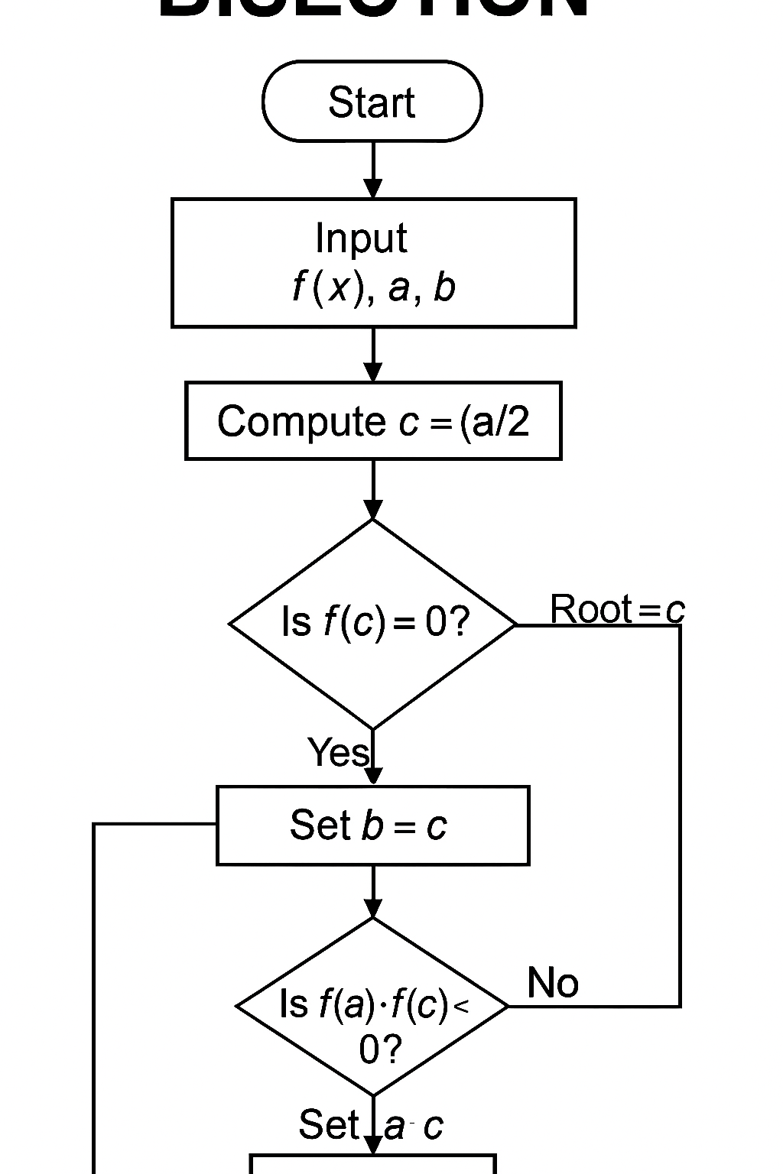

Pseudo code
Input: f(x), interval [a,b], tolerance tol, maxIter
If f(a)*f(b) > 0
Print "No root in [a,b]"
Stop
End If
For k = 1 to maxIter
c = (a+b)/2
If |f(c)| < tol
Root = c
Stop
End If
If f(a)*f(c) < 0
b = c
Else
a = c
End If
End For
Output: Root

            - Fixed Iteration
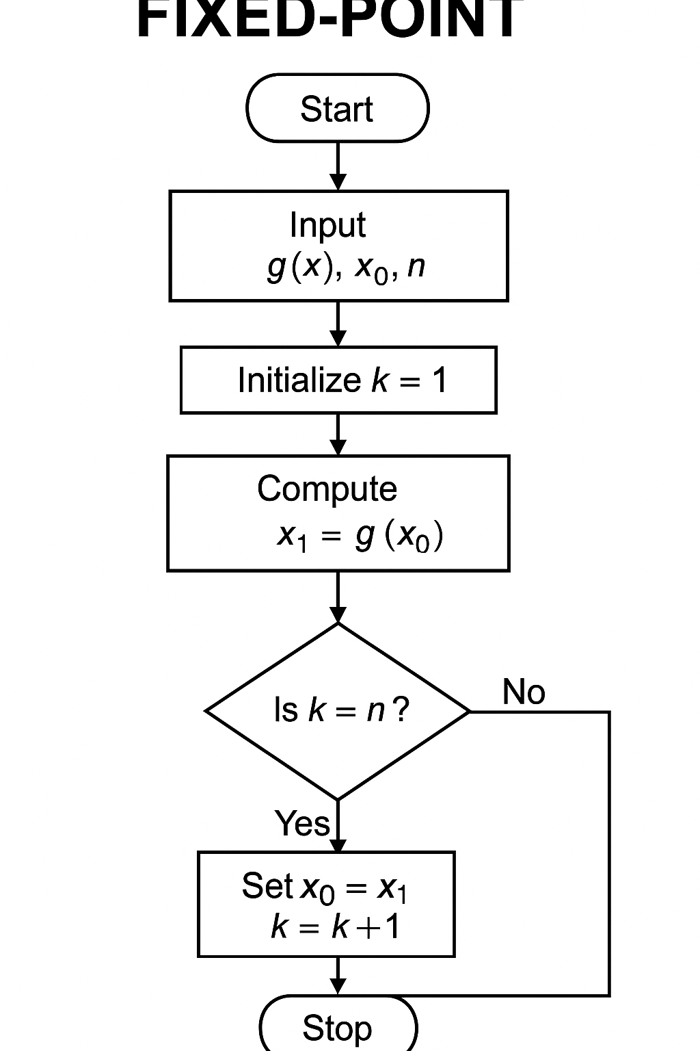
Pseudo Code
Input: f(x), interval [a,b], tolerance tol, maxIter
If f(a)*f(b) > 0
Print "No root in [a,b]"
Stop
End If
For k = 1 to maxIter
c = (a+b)/2
If |f(c)| < tol
Root = c
Stop
End If
If f(a)*f(c) < 0
b = c
Else
a = c
End If
End For
Output: Root
Combined codes for Bisection and Fixed iteration

: CONCLUSION
For the various numerical methods of finding roots, we realized that the number of iterations for a given method vary according to the initial value; x₀ chosen. Newton is very fast. Secant methods are intermediate in speed. Newton and Secant can fail if x₀ is not close to x ∗. We got hardships in coming up with the codes which required us to utilize the programming and data visualization skills with also visiting the internet for the tutorials.

: REFERENCES
- MATLAB Documentation
- MATLAB lecture notes by Mr. Maseruka Bendicto
- You tube MATLAB tutorials

